Steps to Optimal Digestion
Diet changes should also focus on getting the most out of your foods and optimizing digestion first. If digestion is impaired, it makes it more difficult for the body to utilize nutrients efficiently and maintain a healthy immune system and support cellular healing. By incorporating the following steps, you will be better prepared to get the most out of your food (and dietary supplements) while working towards your specific health goals:
- 500mL glass of room temp. water with ½ squeezed lemon water or 1 tbsp apple cider vinegar on waking

- 50% of your plate should be vegetables, 2 different types (i.e. salad plus steamed broccoli)

- Eat the rainbow – goal is 8 different colours of fruits and veggies per day

- Eat in a calm/quiet environment. Avoid eating while distracted, upset, stressed or in front of the tv/phone.

- Chew food slowly and completely until liquefied. This might take 15-30 chews.

- Eat until you are satisfied not until you are full. If you are full you have overeaten.
- Eat mindfully – ask yourself: “do I need or want to eat this?” “Any I hungry or stressed or bored?”

- Drink minimum of 3-4L (females 3L, Males 4L) of water (spring or filtered) throughout the day and ideally away from meals (ie. 20 minutes before meals or 30-60 minutes after meals, small sips are preferred)

- Drinking herbals teas after meals can aid digestion. (eg. Fennel, German Chamomile, Ginger, Peppermint)
  - AVOID Caffeine or Carbonated Beverages while eating

- Make breakfast or lunch the largest meal of the day, eat light for dinner, avoiding any sweet snacks (especially a few hours prior to bedtime)

Balancing the Effects of Stress and Anxiety by Stimulating the Vagus nerve
There are 2 competing nervous systems in your body the sympathetic (SNS) and Parasympthetic (PNS). Excess SNS activity (characterized by “fight and flight mode”, stress, anxiety etc.) suppresses the PNS which is responsible for the rest, repair, and anti- inflammatory actions. The main nerve of the PNS, called the vagus nerve, connects your brain to your internal organs. Certain exercises can be used to activate the vagus nerve to promote healing and reduce the symptoms of excessive SNS activity.

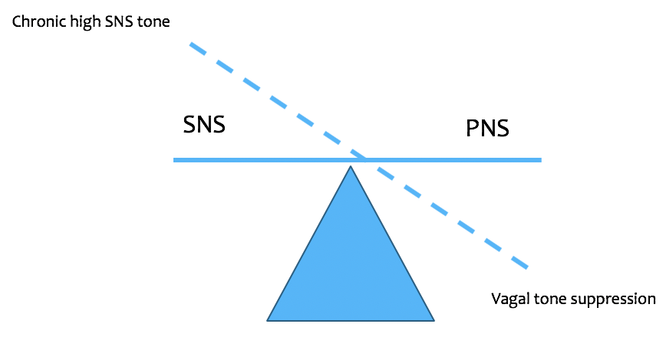

- Deep breathing and meditation – practice at least 5 minutes of silent meditation with deep breathing. Focus on expanding and breathing deep into your belly and keeping your upper chest very still. Ideally, it should be a slow inhale (3sec), hold (1sec), slow exhale (3 sec).
- Hydrotherapy - Cold water exposure: cold decreases SNS and increases PNS.
  - Start with splashing cold water on your face in the morning and evening
  - End your shower with 10sec of cold water to your face, neck, chest and abdomen.
  - Whole body hot-cold showers – alternate 60 sec hot, 10 sec cold. Do 3-4 cycles and always end in cold.
- Earthing / Grounding – walking on grass, sand, or soil with bare feet daily (10min)
- Singing or chanting – do be afraid to sing or hmm your favorite song. Add 120 sec of a simple mantra like “OOOMMMM” to your medication and deep breathing.
- Gargling – powerful vagus stimulator. Gargle water or salt water for 5 minutes in the morning and before bed. It needs to be a deep gargle for optimal stimulation.
- Laughter – be sure to laugh daily because it stimulates the diaphragm and the vagus nerve. Watch or read something funny.
- Prayer – studies show that a recited prayer like the rosary stimulates the vagus nerve. Add positive affirmation or prayer to your daily meditation.
Ask your clinicians about other options including: acupuncture, colonics, massage and vagus nerve stimulation therapy (VNS).

