At Home Progressive Concussion Exercise Program

Note: please do not engage in exercise program if your healthcare provider has told you that you are unsafe to exercise due to cardiovascular reasons, have uncontrolled high BP, or other risk factors. Please consult with your healthcare provider before beginning any exercise program.

This sheet is meant to be kept as a record of your daily exercise workloads so that you may progress yourself over time. The goal is to eventually be able to reach full physical exertion with little to no increase in your concussion symptoms. This sheet is meant to be used in conjunction with the exercise program laid out in Concussion Doc’s Concussion Fix program.
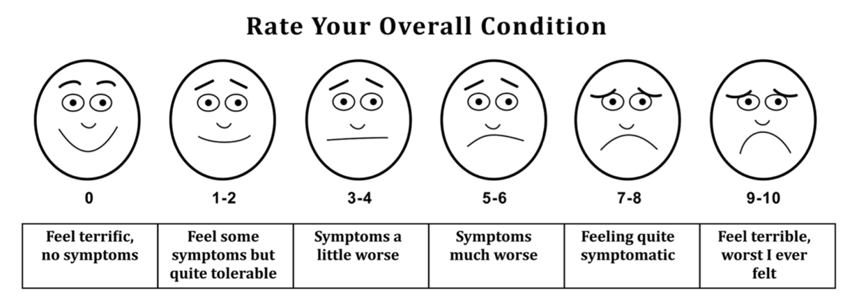
WEEK: _________

Date/Time | Resting HR | Pre-Exercise Overall Condition (0-10) | HR Pace | Length of Exercise (mins) | Post-Exercise Overall Condition (0-10) | Symptoms (if any)

